Temperature Sensor

* Connecting sensor with Arduino:-

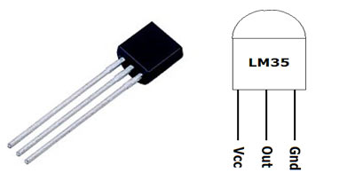

1. Connect VCC of LM – 35 to 5v of Arduino.
2. Connect Out to A1 of Arduino.
3. Connect Gnd to ground of Arduino.

* Connecting Bluetooth Module (HC – 05) to Arduino.

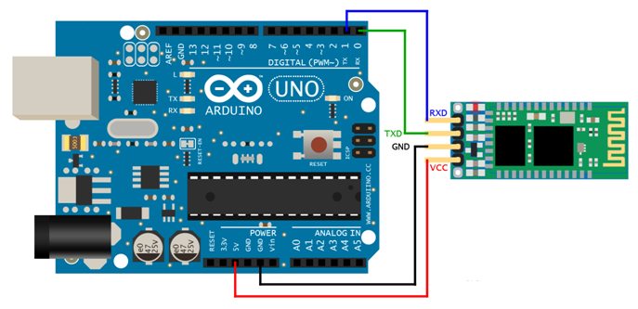

* Overall Circuit Arrangement

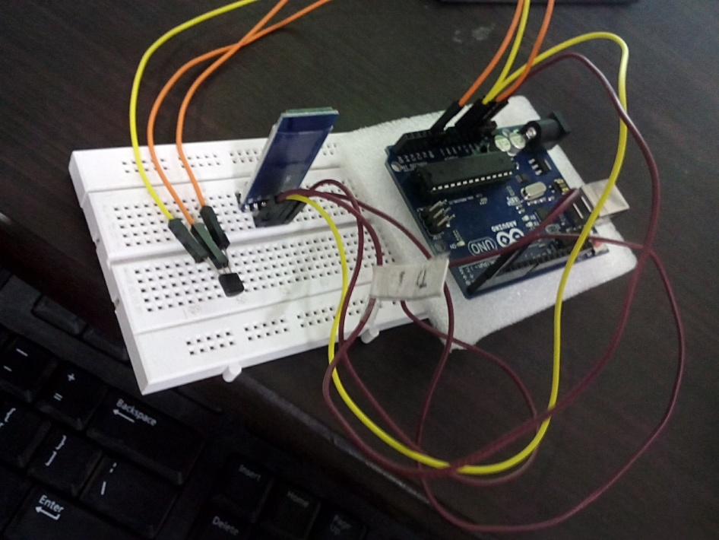

* Code for Arduino. (Remove Rx and Tx pins from Arduino before coding after coding reconnect them)

int val;

int tempPin = 1;

void setup()

{

Serial.begin(9600);

}

void loop()

{

val = analogRead(tempPin);

float mv = ( val/1024.0)\*5000;

float cel = mv/10;

float farh = (cel\*9)/5 + 32;

Serial.print(cel);

Serial.print("°c");

Serial.println();

/\* uncomment this to get temperature in Fahrenheit

Serial.print(farh);

Serial.print("°f");

Serial.println();

\*/

delay(1000);

}

* Android App:-

Application Interface Background Database Implemented

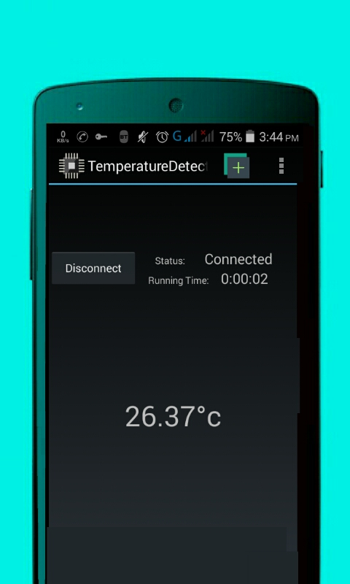 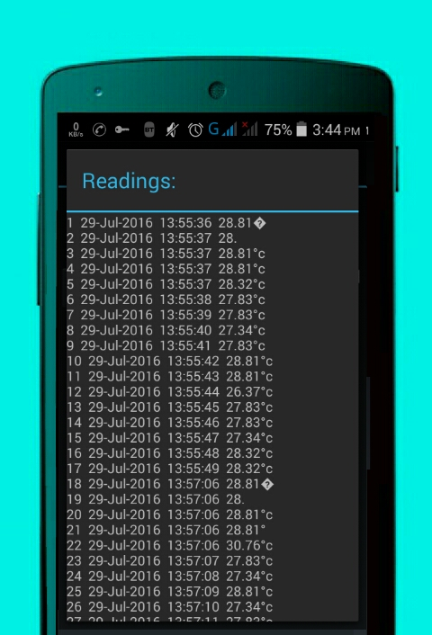

Interface of Application was changed further i.e. Theme etc.

But the basic functioning is same.